Before we get to the crux of this communication, please note there is a pictogram and then content that explains why we are seeking support for this petition.

Here first is a description of the pictogram. The top two thirds of the oblong are bright gold with black lettering and symbols, towards the left are the words “Keep footpaths for feet and mobility devices”. To the right there are two stick-type representations – one of a person walking, and another of a wheelchair user. The bottom third is black, and written in white, are the words “Sign the petition”

Read on for content below the pictogram...

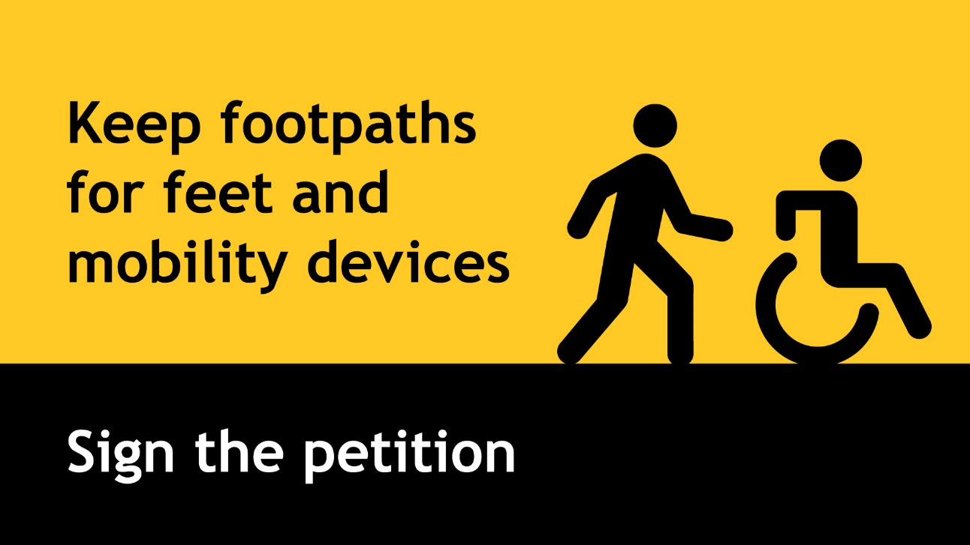

Footpaths4Feet has come together to support members of the community who use footpaths to get around. Organised through Living Streets Aotearoa, Blind Citizens NZ along with several other organisations is part of Footpaths4Feet. We have all been working hard to convince Government that footpaths must remain safe spaces for our members and the public by not allowing e-scooters, bicycles and other personal transport devices to be used on them. Blind Citizens NZ has been part of delegations that have met with Ministers and officials, but we need more support for our work.

The Government is bringing in a regulatory package called the Accessible Streets Package. Although there are some good things in it, this package also seems to permanently allow personal transport devices such as e-scooters to be used on our footpaths. In our view, this will make footpaths less safe, and feel less safe for pedestrians (including those in pushchairs, wheelchairs and anyone using a mobility aid). For many people, such as for blind, deafblind, vision impaired, Deaf, hard-of-hearing etc., using the footpath is a necessity and is the main connection to their community. If e-scooters and other personal transport devices are allowed on footpaths, these people, as well as able-bodied pedestrians, will be put at higher risk of injury and feel less safe

Additionally, if Government adopts these regulations, local councils may feel they no longer need to invest in making spaces safe by, for example, installing bike paths and bike lanes or lowering speed limits.

This is why we are asking for your assistance with this petition to Government. You can sign the petition on-line, or you can download a hardcopy submission form. Your support will help create safer streets for our community! It will help us keep footpaths for feet and mobility device users by getting a ban on e-scooters, bikes and other personal transport devices being used on footpaths.

Sign the petition online here. Download a printable version of the petition here. Please return to Footpaths4Feet, 37 Oxford St, Palmerston North 4410 by 6 December 2019.

Download a printable version of the petition

Sign the petition online now

   | Share
   | Tweet
   | Forward
   | Share

Note for readers: there are logos in the image below of the organisations / groups that have joined “Footpaths4Feet”. The logos appear in lines, across the screen from left to right and are for Living Streets Aotearoa, Grey Power, Blind Citizens NZ, Age Concern, Alzheimers New Zealand, DPA, Blind and Low Vision NZ, CCS Disability Action, Deaf Action, Dunedin Pedestrian Action Network, Health Action Trust, MyLife MyWay, Retina New Zealand, and VICTA (Visual Impairment Charitable Trust Aotearoa)
